Section C — Mini Capstone Project Mini Project:
Q1).Create three tables: restaurants (restaurant_id, name, city, cuisine_type, created_at), menu_items (item_id, restaurant_id, item_name, price, category) with a FOREIGN KEY on restaurant_id, and orders (order_id, customer_name, restaurant_id, item_id, quantity, total_amount, order_date) with a FOREIGN KEY on restaurant_id — all with appropriate PRIMARY KEY and NOT NULL constraints.
Query:-
create table restaurants(restaurant_id int primary key auto_increment,name varchar(30) not null ,city varchar(30) not null,
cuisine_type varchar(50),created_at timestamp default current_timestamp);
create table menu_items (item_id int primary key auto_increment,restaurant_id int not null, item_name varchar(30) not null ,
price int not null,category varchar(30) not null, foreign key(restaurant_id) references restaurants(restaurant_id));
create table orders(order_id int primary key auto_increment,customer_name varchar(30)not null,restaurant_id int not null,item_id int not null,quantity int not null,
total_amount int not null,order_date timestamp default current_timestamp,foreign key(restaurant_id) references restaurants(restaurant_id) ,
foreign key(item_id) references menu_items(item_id) );
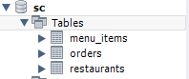
Q2).Populate with at least 3 restaurants, 4 menu categories, and 15 order records distributed across restaurants.
INSERT INTO restaurants
(name, city, cuisine_type)
VALUES
('Spice Garden', 'Surat', 'Indian'),
('Royal Biryani', 'Ahmedabad', 'Mughlai'),
('Pizza Hub', 'Mumbai', 'Italian');
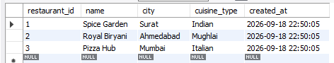
INSERT INTO menu_items
(restaurant_id, item_name, price, category)
VALUES
(1, 'Paneer Tikka', 250.00, 'Starter'),
(1, 'Butter Chicken', 350.00, 'Main Course'),
(1, 'Veg Biryani', 280.00, 'Rice'),
(1, 'Garlic Naan', 100.00, 'Main Course'),

(2, 'Chicken Biryani', 300.00, 'Rice'),
(2, 'Mutton Biryani', 450.00, 'Rice'),
(2, 'Chicken Kebab', 280.00, 'Starter'),
(2, 'Paneer Tikka', 250.00, 'Starter'),

(3, 'Margherita Pizza', 400.00, 'Pizza'),
(3, 'Farmhouse Pizza', 550.00, 'Pizza'),
(3, 'Veg Burger', 250.00, 'Main Course'),
(3, 'Garlic Bread', 180.00, 'Starter');
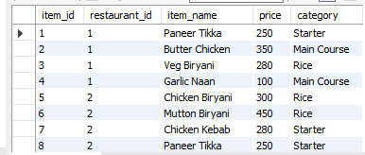
INSERT INTO orders
(customer_name, restaurant_id, item_id, quantity, total_amount)
VALUES
('Rahul', 1, 1, 2, 500.00),
('Priya', 1, 2, 1, 350.00),
('Amit', 1, 3, 2, 560.00),
('Neha', 1, 4, 3, 300.00),
('Karan', 1, 1, 1, 250.00),

('Riya', 2, 5, 2, 600.00),
('Vikas', 2, 6, 1, 450.00),
('Pooja', 2, 7, 2, 560.00),
('Arjun', 2, 8, 1, 250.00),
('Sneha', 2, 5, 3, 900.00),

('Rohan', 3, 9, 1, 400.00),
('Meera', 3, 10, 2, 1100.00),
('Raj', 3, 11, 2, 500.00),
('Anjali', 3, 12, 3, 540.00),
('Dev', 3, 9, 2, 800.00);
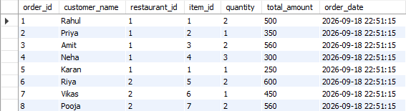
Q3).Create a VIEW named restaurant_sales_summary showing restaurant name, total number of orders, and total revenue grouped by restaurant.
Q4).Write a stored procedure named add_order that accepts customer_name, restaurant_id, item_id, and quantity, calculates total_amount from the menu item price, validates the restaurant exists (ROLLBACK if not), and inserts the order record.
Q5).Write a TRIGGER named after_order_insert that logs a record into an order_audit table (order_id, r

